*JES FALL SHOWCASE*
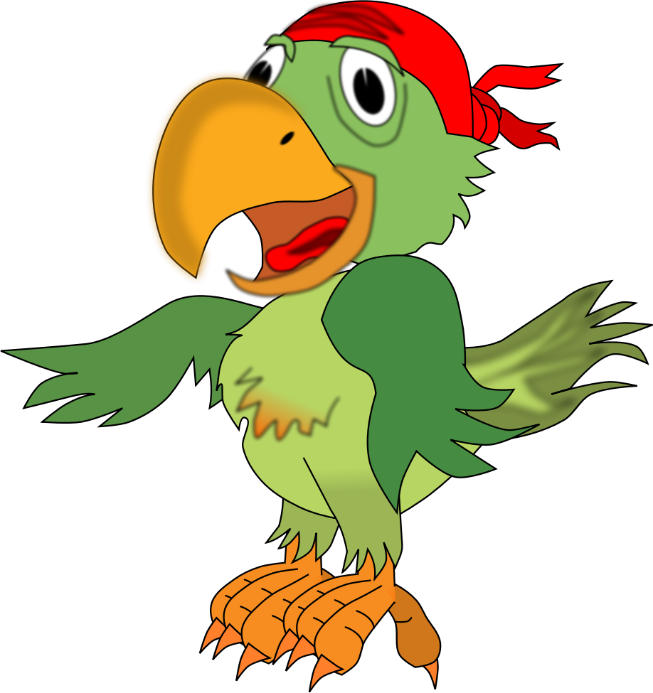

Jefferson Elementary School
Thursday, October 27th, 2016
5:00PM – 7:00PM
**5:00pm – Meet in the Cafeteria for an Informational meeting!**
$5.00 – per family for the meal – Frito Pie, drink & dessert
Visit your child’s classroom, see what they are learning!
- Your child may wear a costume as long as it has a vocabulary word attached to it. Children consider the meanings of words and make costumes accordingly… Be creative!!
**Examples could mean wearing a…
- Type of thing, weather, animal, season, plant, or process… How can you create a costume for that?? Use words you are learning in class!
- For ideas, go to Pinterest, (Parents type in & browse with your kids) and type in Vocabulary Costume and/or Google search for Vocabulary Costumes!
Fun Activities-
The “WORD” – Photo Booth Cup Stacking
&
MORE FUN ACTIVITIES!!
Including…
 THE PIRATE BOOK FAIR 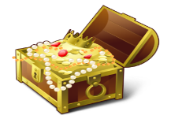
*Argh, me matey’s!!! Reading is the TREASURE!*

